

Name
Talha Abdullah Bangyal
Roll Number
SU92-BAIFM-F25-002
Section
BAI-5B
Subject
Digital Logic Design (Lab)
Submitted To
Kanwal Shahbaz

Table of Contents
Task 1 3
Circuit 3
NOT 3
Expression 3
Truth Table 3
AND 3
Expression 3
Truth Table 3
OR 3
Expression 3
Truth Table 3
XOR 4
Expression 4
Truth Table 4
XNOR 4
Expression 4
Truth Table 4
Task 2 5
Circuit 5
NOT 5
AND 5
Expression 5
Truth Table 5
OR 5
Expression 5
Truth Table 5
XOR 5
Expression 5
Truth Table 6
XNOR 6
Expression 6
Truth Table 6

Note: Don’t copy paste. Submit your task at given time.

Task 1

Circuit
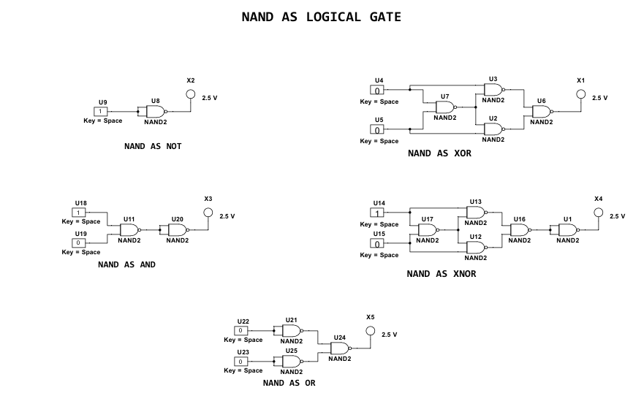

NOT

Expression
Y = $\overline{X.X}$ = $\overline{X}$

Truth Table
X | $$\overline{X.X}$$
0 | 1
1 | 0

AND

Expression
Y = $\overline{\overline{(A.B}).\overline{(A.B)}}$ = A.B

Truth Table
Let Data:
X = A.B
X1 = $\overline{A.B}$
X2 = $\overline{x1.x1}$
A | B | X | X1 | X2
0 | 0 | 0 | 1 | 0
0 | 1 | 0 | 1 | 0
1 | 0 | 0 | 1 | 0
1 | 1 | 1 | 0 | 1

OR

Expression
Y = $\overline{(\overline{A.A}).(\overline{B.B})}$ = $\overline{A+B}$

Truth Table
Let Data:
X1 = A.A
X2 = $\overline{A.A}$
X3 = B.B
X4 = $\overline{B.B}$
X5 = X2.X5
Y = $\overline{X5}$
A | B | X1 | X2 | X3 | X4 | X5 | Y | A+B
0 | 0 | 0 | 1 | 0 | 1 | 1 | 0 | 0
0 | 1 | 0 | 1 | 1 | 0 | 0 | 1 | 1
1 | 0 | 1 | 0 | 0 | 1 | 0 | 1 | 1
1 | 1 | 1 | 0 | 1 | 0 | 0 | 1 | 1

XOR

Expression
Y = $\overline{((A.(A.B)).(B.(A.B)))}$ = A ⊕ B

Truth Table
LET DATA:
X = $\overline{A.B }$
X1 = $\overline{A.X }$
X2 = $\overline{X.B }$
Y = $\overline{X1.X2 }$
A | B | X | X1 | X2 | Y | A ⊕ B
0 | 0 | 1 | 1 | 1 | 0 | 0
0 | 1 | 1 | 1 | 0 | 1 | 1
1 | 0 | 1 | 0 | 1 | 1 | 1
1 | 1 | 0 | 1 | 1 | 0 | 0

XNOR

Expression
DATA:
X = $\overline{A.B}$
X1 = $\overline{A.X}$
X2 = $\overline{B.X}$
X3 = $\overline{X1.X2}$
Y = $\overline{X3}$

Truth Table
A | B | X | X1 | X2 | X3 | Y
0 | 0 | 1 | 1 | 1 | 0 | 1
0 | 1 | 1 | 1 | 0 | 1 | 0
1 | 0 | 1 | 0 | 1 | 1 | 0
1 | 1 | 0 | 1 | 1 | 0 | 1

Task 2

Circuit
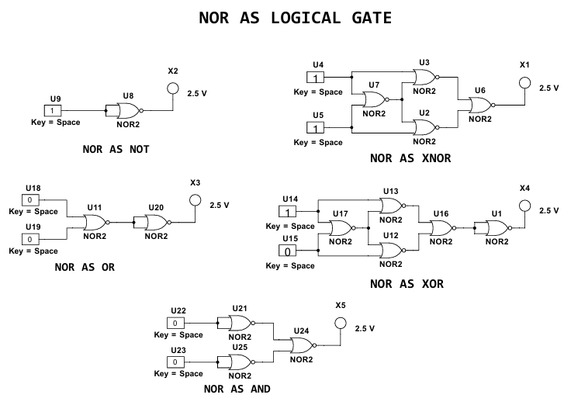

NOT
Expression
Y = $\overline{X+X}$
Truth Table
X | $$\overline{X+X}$$
0 | 1
1 | 0

AND

Expression
Y = $\overline{\left(\overline{A+A}\right)+(\overline{B+B})}$ = $\overline{A.B}$

Truth Table
Let Data:
X1 = A+A
X2 = $\overline{A+A}$
X3 = B+B
X4 = $\overline{B+B}$
X5 = X2+X5
Y = $\overline{X5}$
A | B | X1 | X2 | X3 | X4 | X5 | Y | A.B
0 | 0 | 0 | 1 | 0 | 1 | 1 | 0 | 0
0 | 1 | 0 | 1 | 1 | 0 | 1 | 0 | 0
1 | 0 | 1 | 0 | 0 | 1 | 1 | 0 | 0
1 | 1 | 1 | 0 | 1 | 0 | 0 | 1 | 1

OR

Expression
Y = $\overline{\overline{(A+B}).\overline{(A+B)}}$ = A+B

Truth Table
Let Data:
X = A+B
X1 = $\overline{A+B}$
X2 = $\overline{x1+x1}$
A | B | X | X1 | X2
0 | 0 | 0 | 1 | 0
0 | 1 | 1 | 0 | 1
1 | 0 | 1 | 0 | 1
1 | 1 | 1 | 0 | 1

XOR

Expression
X = $\overline{A+B}$
X1 = $\overline{A+X}$
X2 = $\overline{B+X}$
X3 = $\overline{X1+X2}$
Y = $\overline{X3}$

Truth Table
A | B | X | X1 | X2 | X3 | Y
0 | 0 | 1 | 0 | 0 | 1 | 0
0 | 1 | 0 | 1 | 0 | 0 | 1
1 | 0 | 0 | 0 | 1 | 0 | 1
1 | 1 | 0 | 0 | 0 | 1

XNOR

Expression
Y = $\overline{(\left(A+\left(A+B\right)\right)+(B+(A+B)))}$ = A⊙B ($\overline{A⊕B }$)

Truth Table
LET DATA:
X = $\overline{A+B }$
X1 = $\overline{A+X }$
X2 = $\overline{B+X }$
Y = $\overline{X1+X2 }$
A | B | X | X1 | X2 | Y | A ⊙ B
0 | 0 | 1 | 0 | 0 | 1 | 1
0 | 1 | 0 | 1 | 0 | 0 | 0
1 | 0 | 0 | 0 | 1 | 0 | 0
1 | 1 | 0 | 0 | 0 | 1 | 1

